**Computer Vision – Jonathan Hanbali**

In today's world, computer vision has become an integral part of our everyday life, revolutionizing tasks from object recognition to motion tracking with remarkable accuracy. Within this project, our aim is to harness the power of this revolutionary piece of technology and weave it into our overall workflow. The primary objective behind the computer vision segment of our Hoof IMU project centers on capturing drone footage of a horse in motion—walking or running—and subsequently analyzing the recorded video to **predict** potential issues. Our goal is to create a skeletal pose estimation and to superimpose the model onto the horse in the video, ultimately enabling us to calculate and compare the angles exhibited by a healthy horse versus one experiencing problems, especially laminitis. By utilizing this methodology, we seek to distinguish distinct differences between the skeletal structures and their respective angles, indicative of health or potential issues. Moreover, to deepen the integration within our project, we plan to correlate these computer vision predictions with data obtained from our inertial measurement device, enhancing our ability to forecast laminitis.

**METHODOLOGIES**

To achieve our computer vision goal, we explored various methodologies, encompassing established software/project, hardware solutions, and coding methodologies. However, our journey was rife with challenges. The path towards implementing these methods proved to be an ongoing process, demanding continual exploration to identify the most effective approach in achieving our objective.   
  
Thus far, we've experimented with three distinct methods in sequence:

1. Hardware Solution: NVIDIA Jetson Nano
2. Established Project Solution: DeepLabCut
3. Coding Solution: MATLAB Color Difference

Each of the methods mentioned above have its own sets of challenges and obstacles, which we will go over in each of the subsequent subsections below.

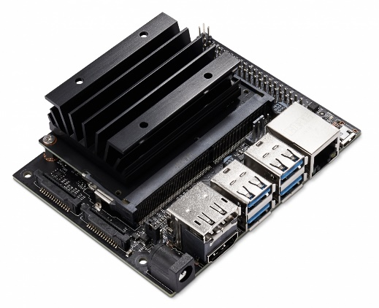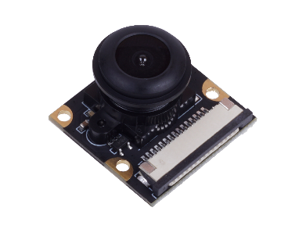***Hardware Solution: NVIDIA Jetson Nano***

Figure 3 10- NVIDIA Jetson Nano Developer Kit (left) and 8MP CSI Camera - IMX219-130 (right)

Our initial strategy revolved around leveraging the capabilities of the NVIDIA Jetson Nano, an embedded computing board tailored for entry-level edge AI and computer vision applications. Jonathan personally purchased the NVDIA Jetson Nano development kit to assess whether Jetson Nano could serve as a pivotal tool to achieve our objectives. Our initial intention of utilizing Jetson Nano was to alleviate the computational load and streamline the process of our video capture and processing, particularly in the realm of AI integration. In our efforts to integrate Jetson Nano, we discovered that Jetson Nano comes with many problems, especially in software dependencies, as almost every Linux distribution has encountered. Linux often encounters software dependency issues due to its open-source nature and the diversity within its ecosystem. There are several factors that contribute to these issues, but mainly because it is possible to have more than one version of a software to coexist in Linux environments which could lead to a conflict, such that it was quite a challenge to ensure that we have the right version of the software required for a task. These challenges increased exponentially especially when we need to install more software, since now, the newer software that we need to install also have a dependencies to a certain version of software as “corequisite” or even a “prerequisite” in order for that software to run properly, such that, after installing multiple versions of software, we then stuck in the loop of trying to find a version of software that are needed in order for us to be able to do our task.

**Our milestone in utilizing Jetson Nano:**

* **JetPack Installation**: We successfully installed JetPack, the Ubuntu 22.04 Linux-based operating system for the Jetson platform.
* **Memory Swap Expansion:** We were able to increase the memory swap on the Jetson Nano to enable it to offload less critical data from RAM to our Micro SD Card on Jetson Nano, ensuring smoother operation and better memory management.
* **Software Setup:** We were successful in installing necessary dependencies and software essential for our machine learning task.
* **Camera Integration:** We were able to connect a CSI-based camera to analyze captured image utilizing Python Script running on Jupyter Notebook

**Challenges:**

* **Software Dependencies:** As mentioned above, we encounter a significant software dependencies issue which complicates our setup and slows down our progress.
* **Insufficient Beginner Resources:** We came in with a limited knowledge in Linux Operating System, Python programming language, and Machine Learning/Artificial Intelligence. With the lack of documentation and tutorials for beginners, it increases our initial learning curve and slows down our progress significantly.
* **Performance Issues with Image/Video Processing:** We experienced sluggish performance especially when processing the live video captured using our CSI camera setup.

**Future Directions:**

Faced with the complexities and problems encountered during our hardware solution research, we made a resolute decision to pivot and explore alternative methodologies in our pursuit of achieving our computer vision objectives, however, if we would need to come up with a different solution that utilizes our hardware solution, Jetson Nano, I suppose that we would have to create a custom environment by using Docker containers or even Conda environment. Utilizing Docker containers would enable the development of a compact, self-sufficient software package containing all essential components for application operation, ensuring lightweight and portable execution, eliminating the issues of software dependencies.

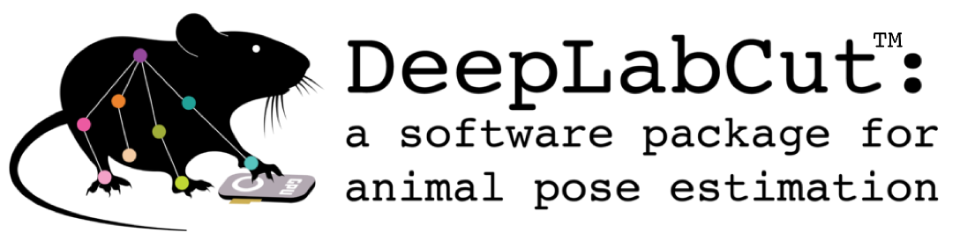***Established Project Solution: DeepLabCut***

Figure 11 - DeepLabCut Logo

After encountering many software dependencies problems when exploring our hardware options, Jetson Nano, we then pivoted and tried to see if other people already had done the same, estimating a skeletal body (pose estimation) on animals. One of the biggest hurdles that we can note is the fact that most of the machine learning models out there were focused on creating the pose estimation of the human body (even with the Microsoft Kinect, like what Matt tried during summer break), such that it was hard to find a training model for our purposes, since a training model is needed to train the computer’s neural network to be able to recognize different kinds of horses with different color and characteristics.

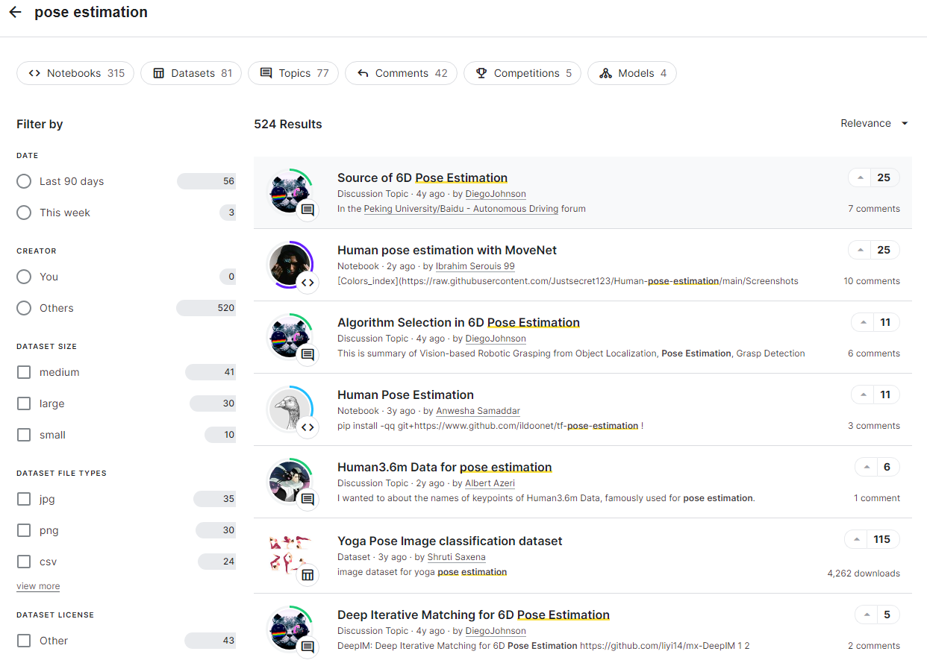

Figure 12 – Pose Estimation Search Results from Kaggle.com

We then tried to search far and wide, reading many papers about pose estimation, and found DeepLabCut which was developed by the Mathis Group and Mathis Lab at EPFL, Swiss Federal Institute of Technology Lausanne. Borrowing the word from their creator, [1]**DeepLabCut™ is an efficient [open source] method for 2D and 3D [marker-less] pose estimation based on transfer learning with deep neural networks that achieves excellent results (i.e. you can match human labeling accuracy) with minimal training data (typically 50-200 frames). T**here are several publications that utilized DeepLabCut, and many of them revolved around biomechanics of mainly animals, and pertaining to the utilization of DeepLabCut in predicting behavior. For more information about the publications involving DeepLabCut, see appendix __**H**___

As we mentioned before, that more often than not, Linux distributions often encounter software dependencies. DeepLabCut is no different. Since it was built on Python programming language, it also needed custom prerequisites software for the application to run smoothly, such that they utilized Conda environments, in which in itself is a directory that contains **specific collection** of Conda packages. Notice how they also would have to create a custom environment for their program to function. In our effort to utilize our established project solution, DeepLabCut, we were able to reach some milestones, while also facing some challenges, mostly hardware.

**Our milestone in utilizing DeepLabCut:**

* **Anaconda Installation**: We successfully installed on a windows laptop, Anaconda navigator, a distribution of the Python and R programming languages along with a collection of open-source packages used for scientific computing, data science, and machine learning tasks. This application contains Conda, the package and environment management system that were required for us to install DeepLabCut and provides a range of **pre-built** packages and libraries such as NumPy, Pandas, TensorFlow, scikit-learn and many others which are essential for machine learning purposes.

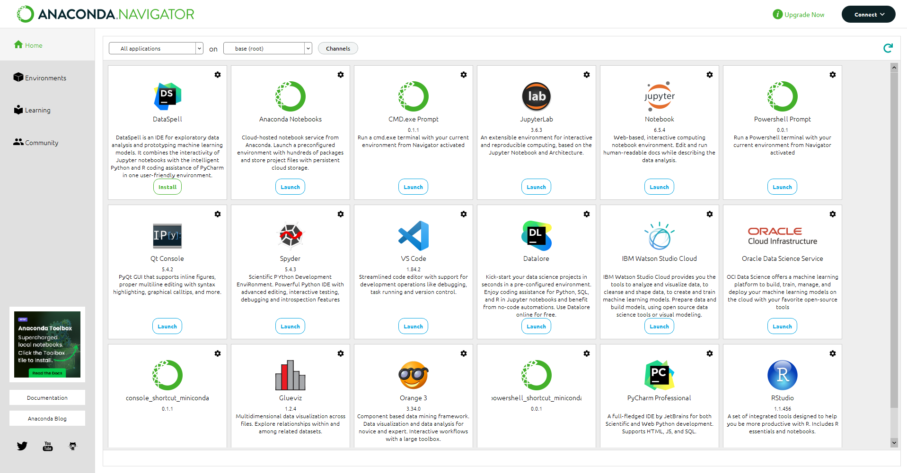

Figure 13 - Anaconda Navigator

* **DeepLabCut Installation:** We were able to install DeepLabCut successfully, and tried the software for a period until we encountered a different challenge; hardware.

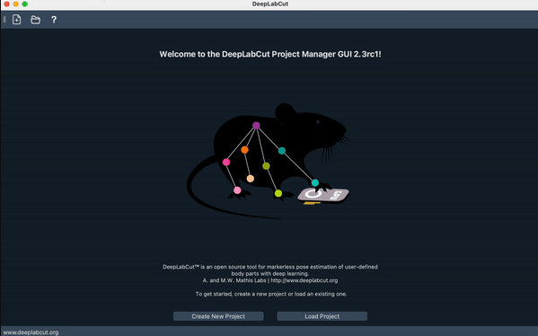

Figure 14 - DeepLabCut Graphical User Interface

**Challenges:**

* **Hardware Limitation:** As mentioned above, we encountered some hardware limitations. Jonathan’s laptop, where we installed DeepLabCut was an older computer, such that it was quite a demanding task to run the DeepLabCut on his computer.
* **Time Constraint:** We also have time constraints such that we don’t have time to fully understand and learn how to utilize DeepLabCut to achieve our objectives.

**Future Directions:**

Despite the challenges that we encounter, we found some valuable resources that could be utilized in the future exploration of the computer vision section of the overall project, training datasets. Alexander Mathis and his group introduced Horse-10, a training dataset that [2] **comprises 30 diverse Thoroughbred horses, for which 22 body parts were labeled by an expert in 8,114 frames (animal pose estimation).** With this dataset, we would be able to train a machine learning model in the future if we choose to go back and utilize Jetson Nano.

***Coding Solution: MATLAB Color Difference***

Following unsuccessful attempts with both Jetson Nano and DeepLabCut, our advisor, Professor Zeke, suggested exploring MATLAB as an alternative avenue to achieve our objectives. MATLAB, a matrix-based programming platform, holds a niche in its design tailored for engineers and scientists, facilitating analysis and system design. Our exploration of MATLAB's coding solutions led us to its Image Processing and Computer Vision applications, notably the Color Thresholder. This tool enables the creation of masks utilizing the screenshot of our drone-captured videos, allowing focused analysis based on specific criteria, in our case, color. There are four main color space that are available within the Color Thresholder application, RGB (Red Green Blue), HSV (Hue Saturation Value), YCbCr (Luminance Chrominance), and L*a*b* (Lightness, green-red axis, and blue-yellow axis) as pictured in the figure below.

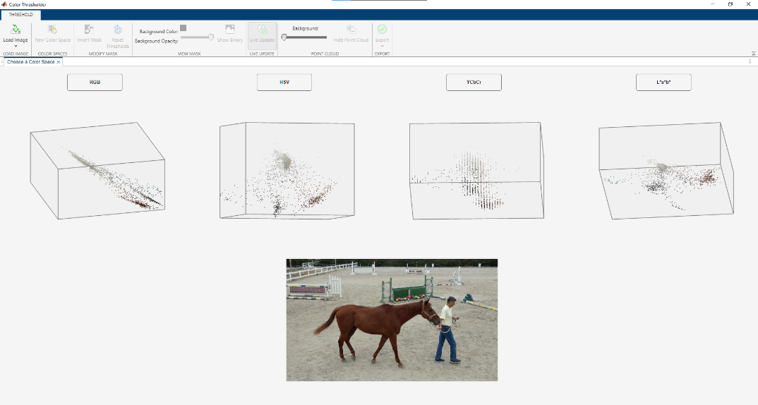

Figure 15 - MATLAB Color Thresholder

We experimented with various color spaces and screenshot combinations to optimize masking for horses with different shades of brown coats and notice that the combination between the screenshot from the Horse Video #6 and L*a*b* color space yielded the best masking for almost all our other videos. As we can see below, the screenshot acted as a freeze-frame, offering a snapshot from the overall video footage. In the picture, we can see Professor Faramarzi guiding the horse while walking around the premises and the predominant colors captured include the brown shade of the horse’s coat, professor Faramarzi’s blue jeans, and the green equine gate.

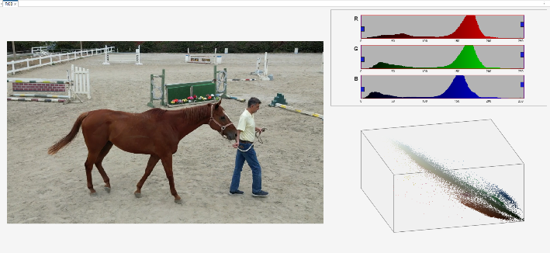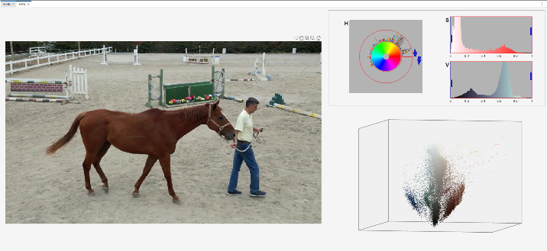

Figure 16 - RGB color space (left) and HSV color space (right)

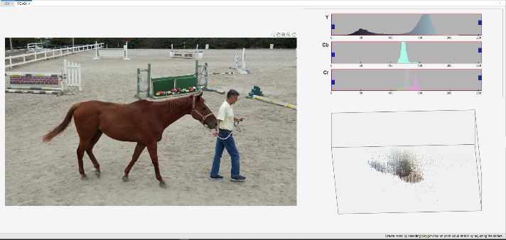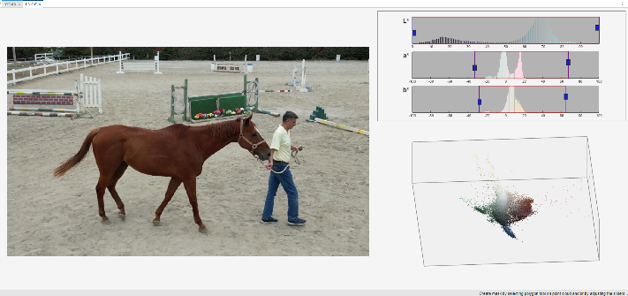

Figure 17 - YCbCr color space (left) and L*a*b* color space (right)

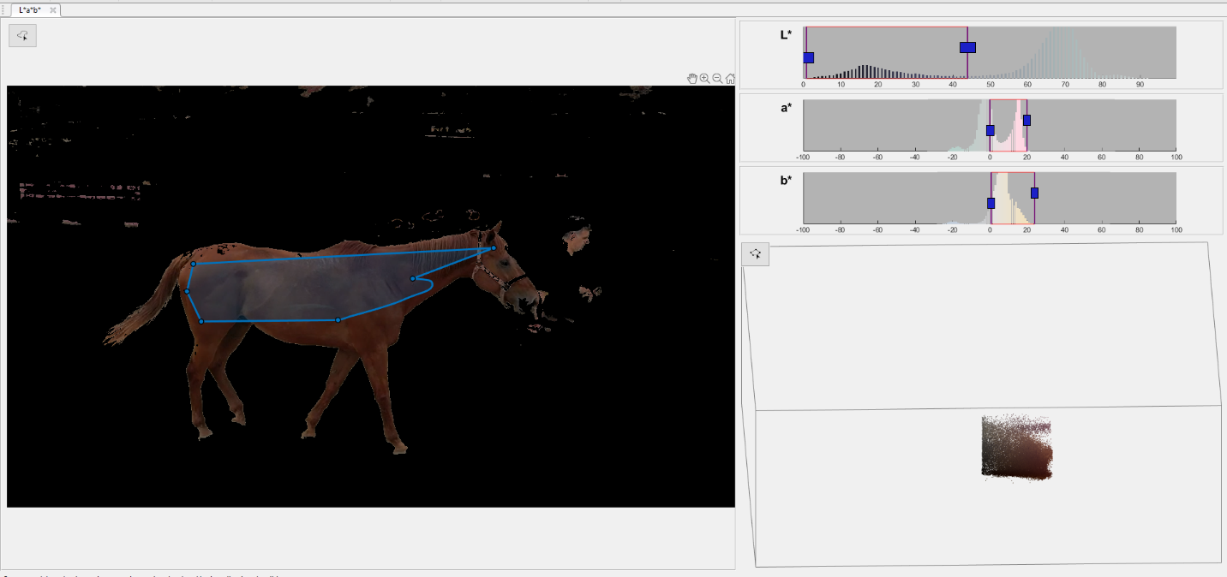

Figure 18 - Combination that yield the best result: Horse Video #6 and L*a*b* color space

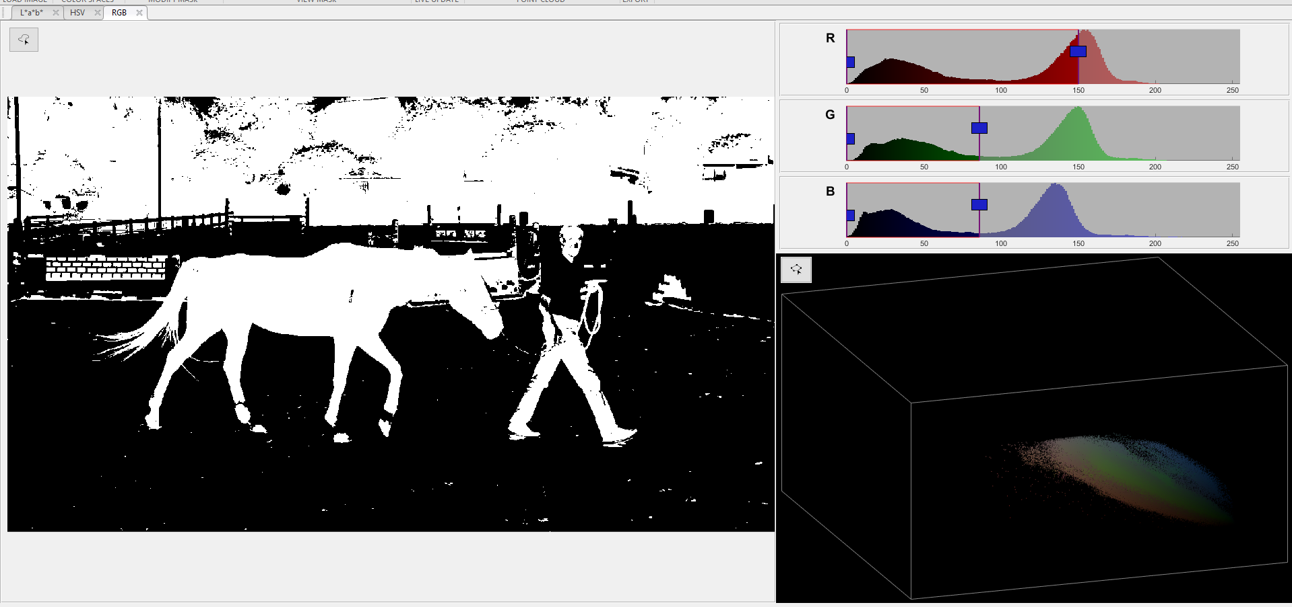

Figure 19 - Horse Video #10 masked with RGB color space

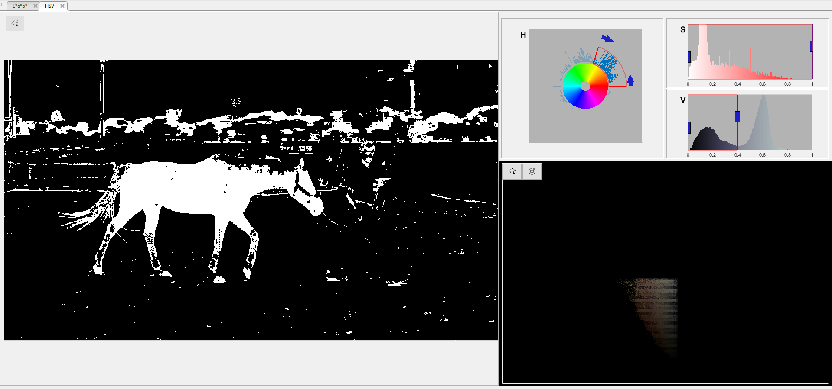

Figure 20 - Horse Video #10 masked with HSV color space

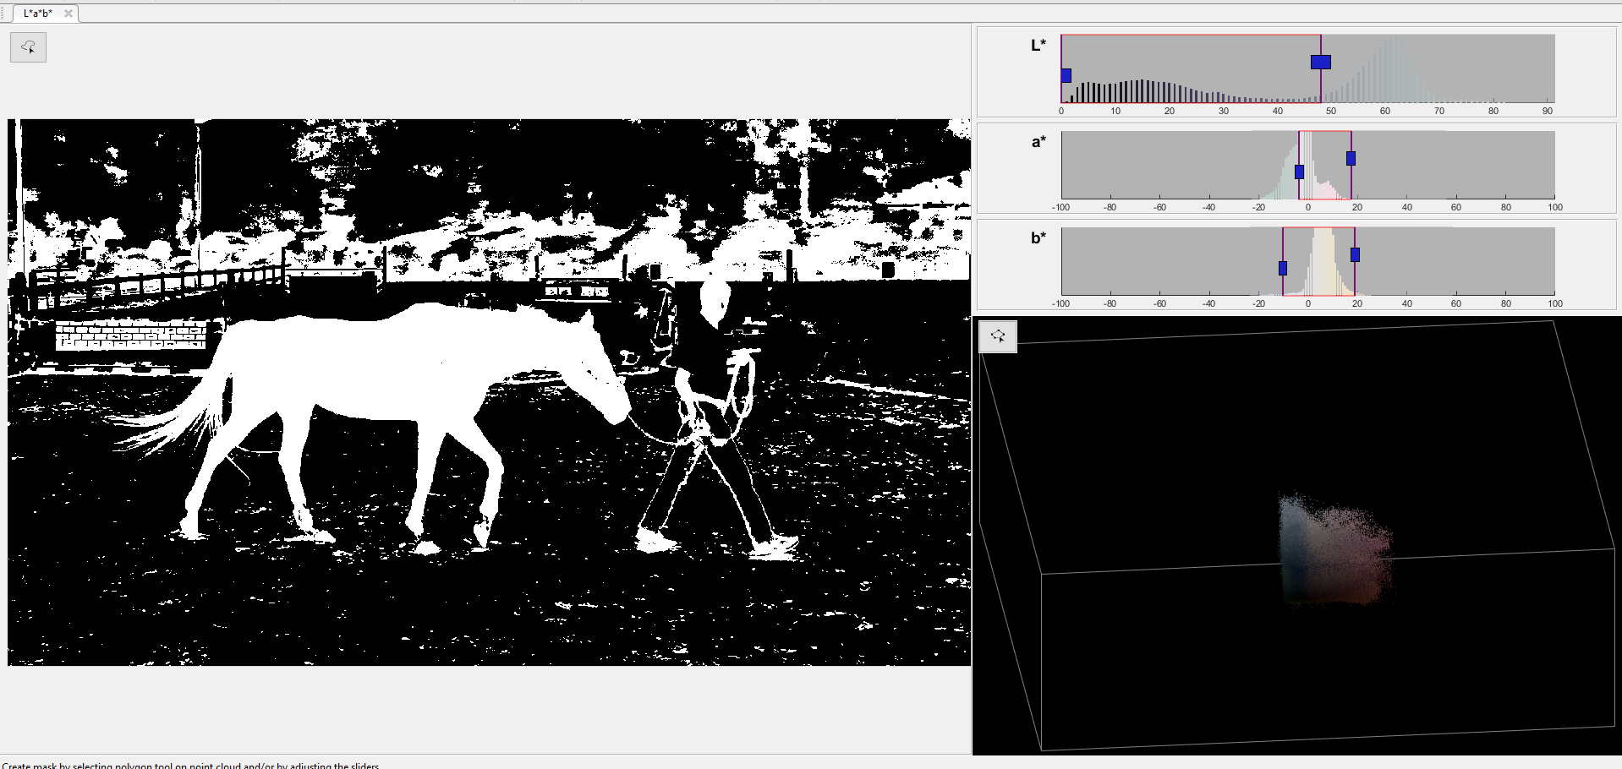

Figure 21 - Horse Video #10 masked with L*a*b* color space

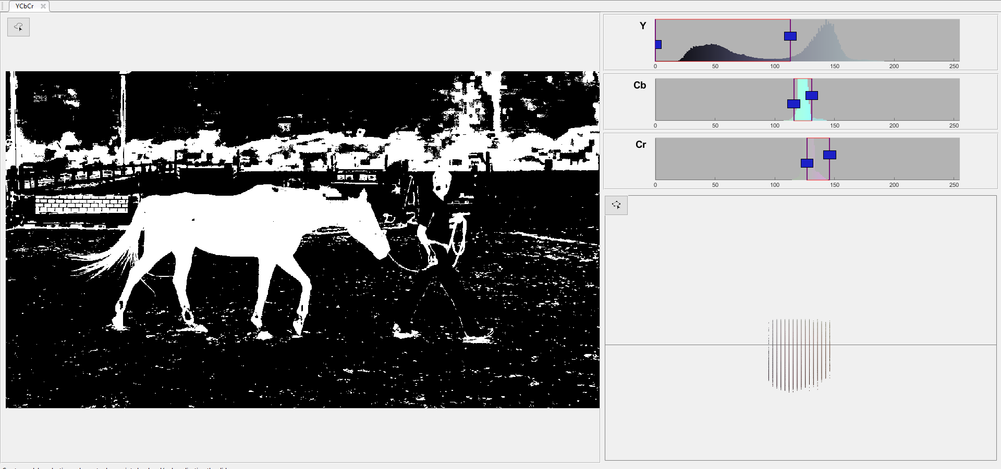

Figure 22 - Horse Video #10 masked with YCbCr color space

It is evident from figure xx – xx, that the effectiveness of the masking process varies across different videos. Certain videos produce more satisfactory results than others, and the choice of color space also significantly impacts the outcome. Figure 17 showcases the notably superior result achieved by combining Horse Video #6 with the L*a*b* color space. This combination successfully generated a mask that could potentially envelop the horse entirely, leaving only a certain number of noises that could then be “removed” with a blob analysis. Contrastingly, the combination involving Horse Video #10 with various color spaces resulted in significantly more noise, proving less effective in achieving a refined mask. This discrepancy underscores the variability in outcomes and the importance of selecting the most suitable video and color space pairing for optimal masking.

After researching on the best possible masking that we could apply to our drone-captured footages, we then developed a MATLAB that enables us to do different tasks, mostly revolves around morphological operations and manipulating picture frames. For more information about the function being used and its application, go to appendix XXXX.

Upon finalizing our MATLAB script by using bwmorph to draw a skeleton with branchpoints, we were able to “draw” a rough pose estimation on the top of our original videos. Even though our masking was almost perfect and contained less noise, it still has some noises, such that, we can note some random skeletal figures that appear out of nowhere since they also contain the same color as our horse color. So, we then refined our methodologies by employing blob analysis. This process allowed us to discern and eliminate smaller image blobs, focusing solely on isolating the largest blob within the binary image. This refinement aimed to ensure that only the primary and most significant image blob, representing our intended subject, remained within the frame. Below are the examples of our effort with and without the blob analysis.

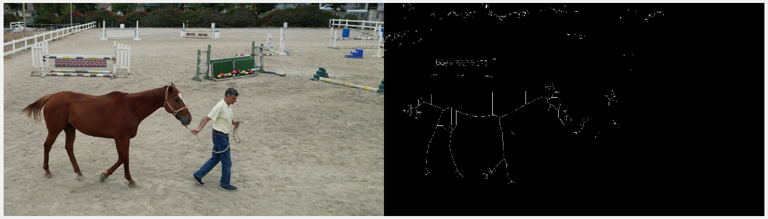

Figure 23 - Image of the original frame (left) and its skeletal structure without blob analysis (right)

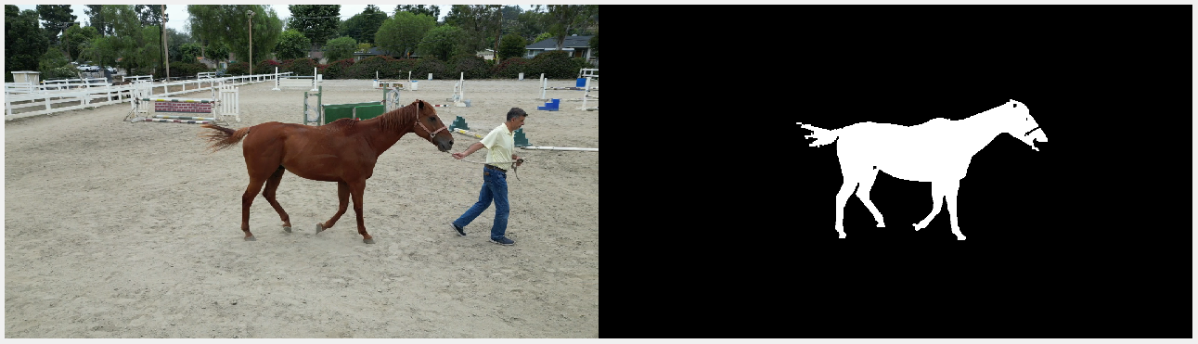

Figure 24 - Original Frame (left) and the biggest object after blob analysis

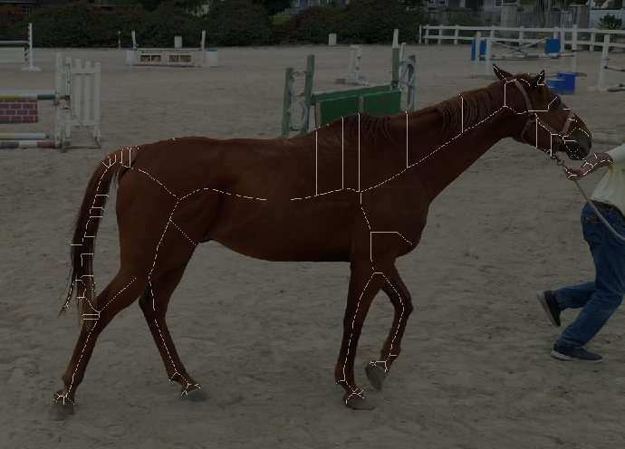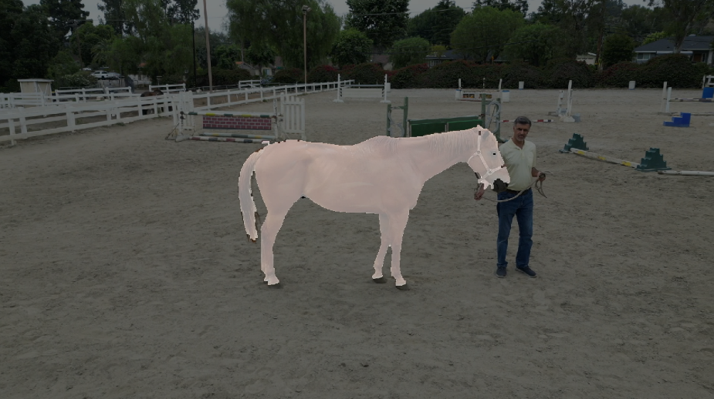

Figure 25 - After blob analysis: overlayed skeletal (left) and overlayed biggest blob (right)

To validate our method, we created a separate mask using an entirely different object—a bottle with a blue color resembling Professor Faramarzi’s jean. After allowing the video to progress through multiple frames and observing Professor Faramarzi exiting the frame, we noticed another 'skeleton overlay' appearing over objects sharing a similar dark blue color. This occurrence indicates the success of our blob analysis since the core principle of blob analysis involves identifying the largest blob of a selected color, and we were able to achieve this accurately with a completely different mask as pictured in the figures below.

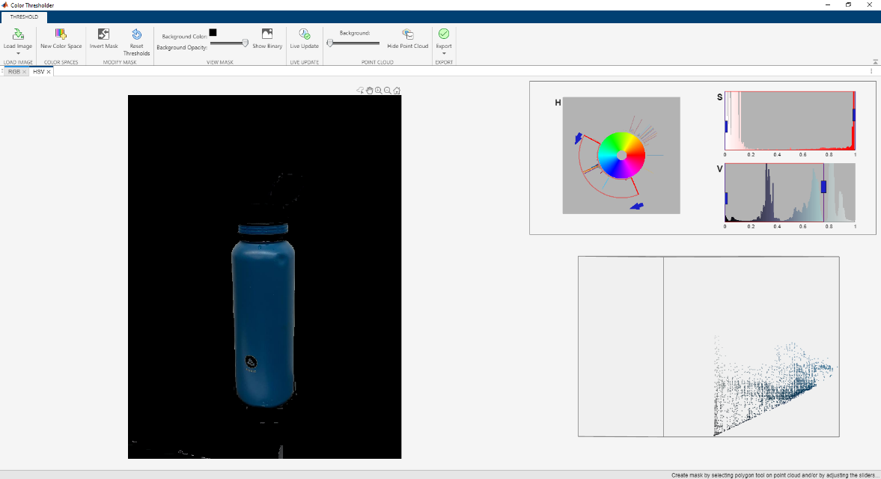

Figure 26 - Test utilizing a random mask

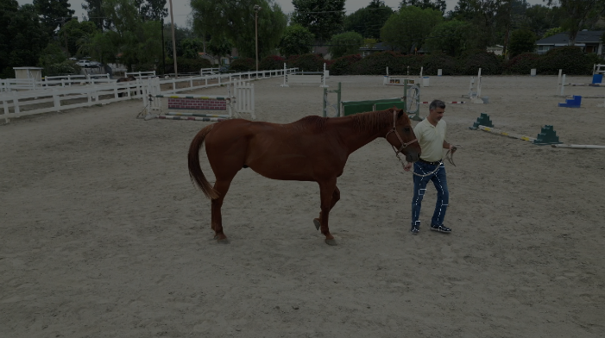

Figure 27 - Blob analysis and skeletal figure over Professor's Faramarzi's blue jeans

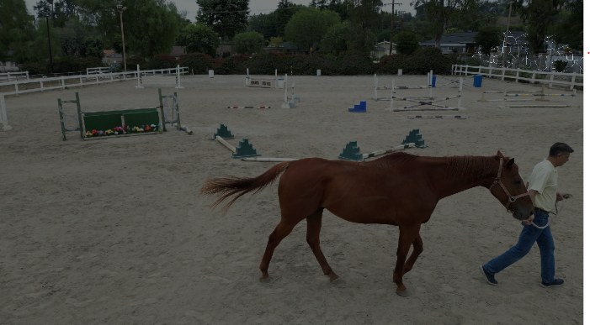

Figure 28 - Blob analysis and skeletal figure over the biggest blob on the frame (top right)



Figure 29 - Horse and the pose estimation using color difference

Despite our success in creating rough skeletal estimation through our MATLAB script, we encountered challenges, particularly in distinguishing between the front and back legs, as illustrated in the figure above. MATLAB's method relies on color masking, leading to difficulty in accurately differentiating between body parts. Consequently, at times, the skeletal estimation connects to the wrong area of the body, impeding clarity. In the depicted figure, both front legs appear connected, which deviates from the actual anatomical structure where they should be linked to the shoulder blade. This discrepancy results in an inaccurate representation of the horse's actual anatomy. We also noticed that by using this method, we will not be able to estimate the skeleton clearly, since we’re just using the default MATLAB function, such that there are still a lot of artifacts like the “branch” on the skeleton estimation that does not even represent anything. To combat this issue, we then tried a method to “remove” shorter skeleton, but we found out that the center section of the horse skeleton consisted of many dashes or shorter lines, such that, those supposedly long lines are in fact the shorter ones. With that, our effort to remove the shorter lines does not yield the result that we envisioned, so we scratched this method, although perhaps if we develop it further, we might be able to utilize the dots, and draw a more relevant lines and figure to accurately represent the horse skeleton.

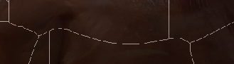

Figure *30* - The center section that contain dashed lines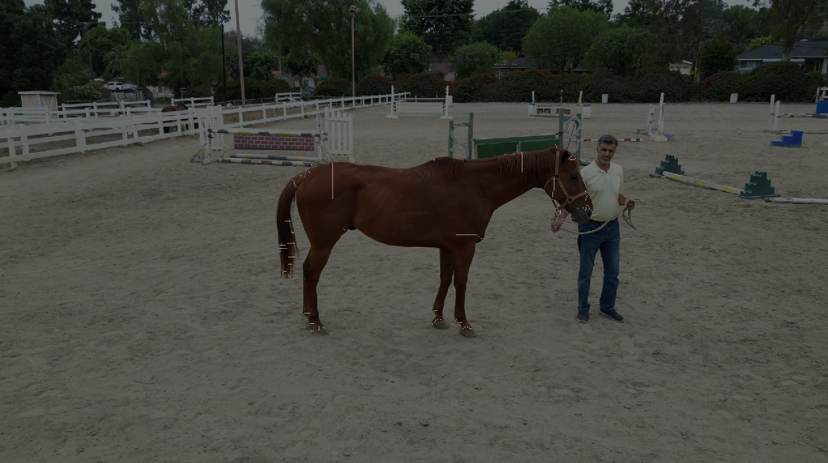

Figure 31 - Removal of the shorter lines

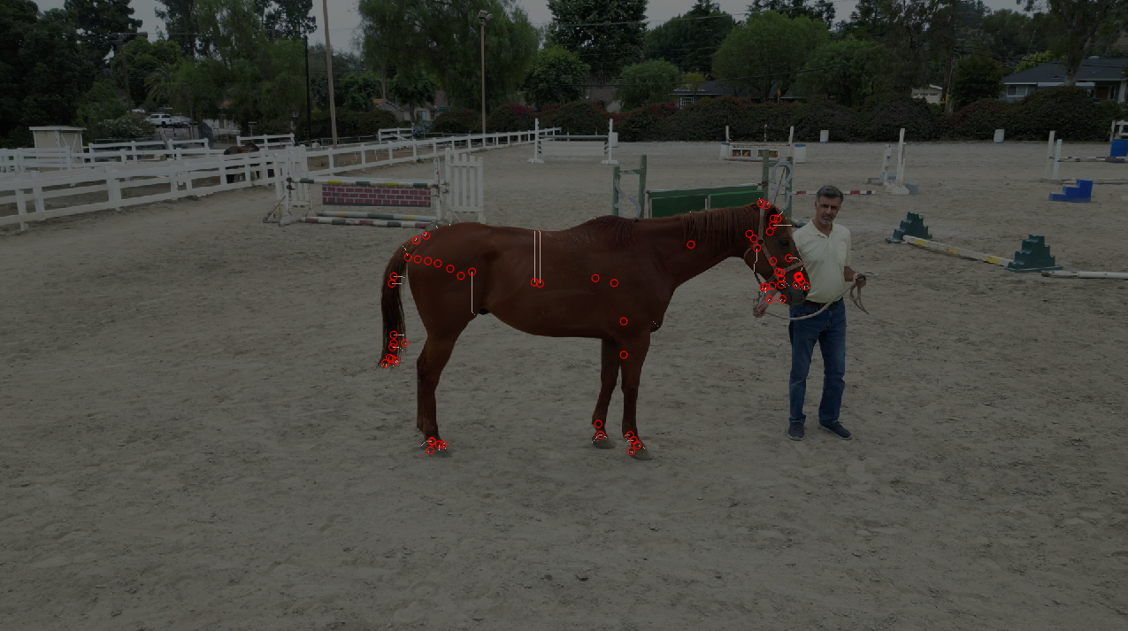

Figure 32 - Removal of the shorter lines and adding dots onto the frame

**Our milestone in utilizing MATLAB**

* **Utilizing Color Thresholder applications to create mask:** We were able to employ the color thresholder applications effectively to generate an appropriate mask that are beneficial for our project.
* **Creating MATLAB script**: We were able to create a MATLAB script that enables us to utilize the mask obtained from the color thresholder application.
* **Implementing Blob Analysis**: We were able to implement the blob analysis that enabled us to isolate the predominant blob in our video frames.
* **Rough pose estimation**: We were able to create a rough pose estimation by utilizing only MATLAB functions from Image Processing and Computer Vision toolbox.

**Challenges:**

* **Marker-less estimation:** As mentioned above, we concluded that this method would not work well with a marker-less video. To improve this project outcome, we would have to switch method, by utilizing a marker to be able to accurately create a pose estimate of the horse.

**Future Directions:**

Looking forward to future advancements, we will be shifting our focus from marker-less to marker-based pose estimation. This transition aims to enhance accuracy by incorporating a cyan-colored marker, ensuring clearer delineation—especially beneficial considering that horse coat colors often fall within the red-brown spectrum. Once this marker-based system is established, our plan is to employ the cosine law to calculate and estimate the angles between the horse's thigh and leg. These estimations will then be compared against measurements gathered from our IMU device, enabling a more comprehensive evaluation of the horse's movement dynamics, and ultimately predict the sickness of the horse.